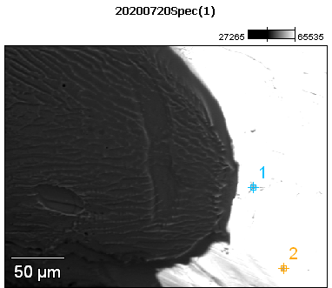

Image Name: 20200720Spec(1)

Image Resolution: 512 by 384

Image Pixel Size: 0.59 µm

Acc. Voltage: 12.0 kV

Magnification: 420

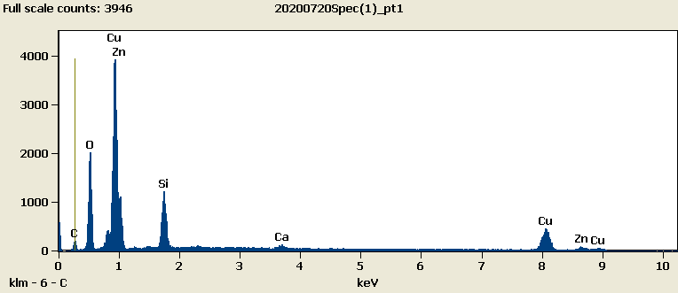

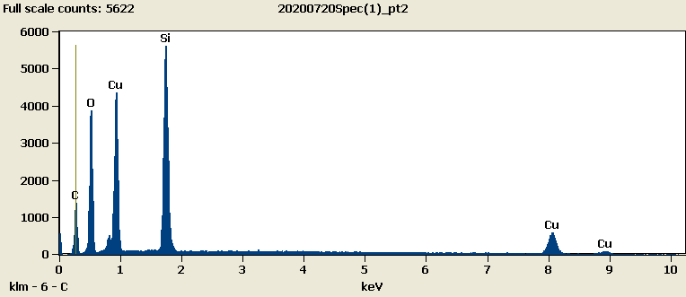

Weight %

|  |  |  |  |  |  |  |
| --- | --- | --- | --- | --- | --- | --- |
|  | ***C-K*** | ***O-K*** | ***Si-K*** | ***Ca-K*** | ***Cu-L*** | ***Zn-L*** |
| ***20200720Spec(1)_pt1*** | 5.80 | 15.71 | 8.33 | 1.28 | 43.93 | 24.95 |
| ***20200720Spec(1)_pt2*** | 23.25 | 22.34 | 21.25 |  | 33.16 |  |

Weight % Error (+/- 1 Sigma)

|  |  |  |  |  |  |  |
| --- | --- | --- | --- | --- | --- | --- |
|  | ***C-K*** | ***O-K*** | ***Si-K*** | ***Ca-K*** | ***Cu-L*** | ***Zn-L*** |
| ***20200720Spec(1)_pt1*** | ±0.31 | ±0.19 | ±0.13 | ±0.10 | ±0.39 | ±0.52 |
| ***20200720Spec(1)_pt2*** | ±0.33 | ±0.21 | ±0.12 |  | ±0.24 |  |

# Cations

|  |  |  |  |  |  |  |
| --- | --- | --- | --- | --- | --- | --- |
|  | ***C-K*** | ***O-K*** | ***Si-K*** | ***Ca-K*** | ***Cu-L*** | ***Zn-L*** |
| ***20200720Spec(1)_pt1*** | 0.00 | 0.00 | 0.00 | 0.00 | 0.00 | 0.00 |
| ***20200720Spec(1)_pt2*** | 0.00 | 0.00 | 0.00 |  | 0.00 |  |